Group Priorities Report
Group Priorities Report is centered on the websites traffic statistics that represent company’s portfolio offers.
The report is sourced using APIs and Google Analytics data and is represented by the following tables:
- GP_API_transformation - r
- GP_Pageviews_dataset – r
- GP_Users_dataset - r
Index_GP - r
Additional datasets
- Last Refresh Table
- Date Table – for Pageviews table statistics
- Date Table 2 - for Users table statistics

Relationships
Table (column) | Relationship | Table (column) | Status
GP_API_transformation- r (id) | Cardinality:  Many to Many  Cross-filter direction: Both | GP_Pageviews_dataset - r (id) | Active
GP_API_transformation- r (id) | Cardinality:  Many to Many  Cross-filter direction: GP_API filters RLS | GP_Users_dataset – r (id) | Active
GP_Pageviews_dataset - r (Date) | Cardinality:  Many to one  Cross-filter direction: GP_API filters Date Table | Date Table | Active
GP_Users_dataset - r (Date) | Cardinality:  Many to one  Cross-filter direction: GP_API filters Date Table 2 | Date Table 2 | Active

Data model
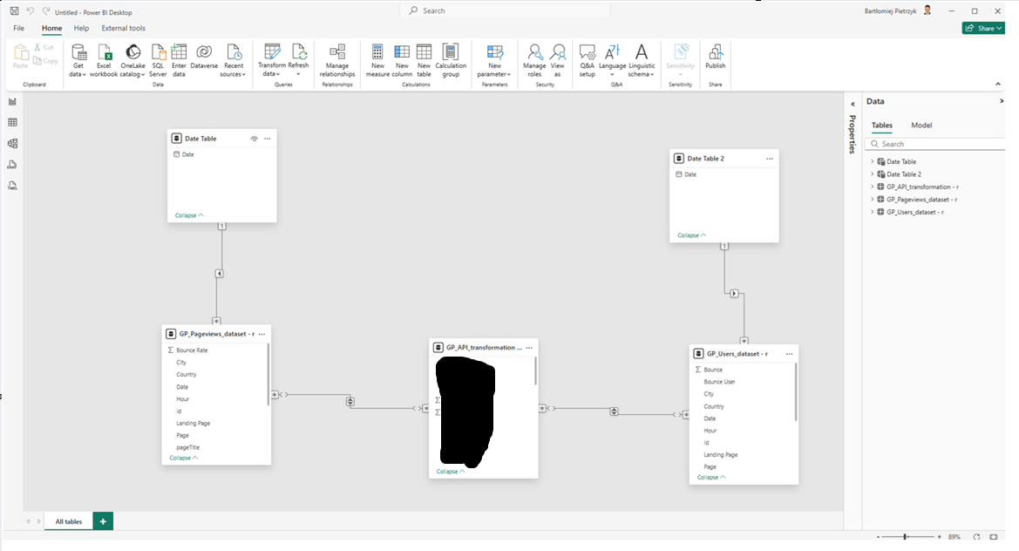

Dataflow architecture
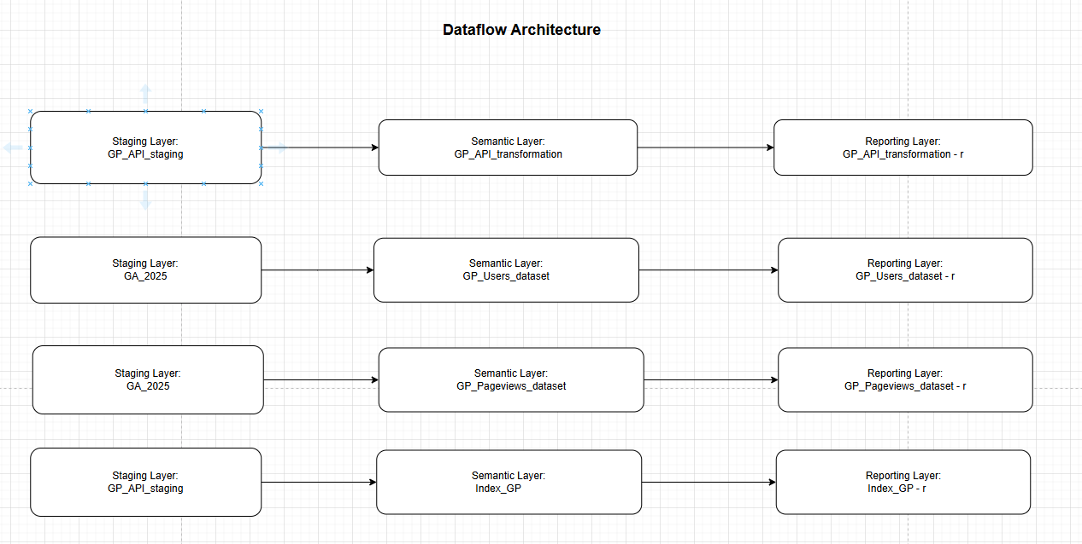
Summary
- GP_API_transformation - r table is joined with GP_Pageviews_dataset - r to meet further reporting needs.
- GP_API_transformation - r joined with GP_Users_dataset - r to meet further reporting needs.
- GP_API_transformation - r table is joined with Index_GP - r to meet further reporting hierarchical needs.
Core functionalities and Visual representation
The difference between Global Industries Report, Business Lines Report and Group Priorities Report is in offers type and categorization towards specific line. All functionalities for all three reports are the same.

Semantic model creation process
On blank report, I import tables from Datamart.
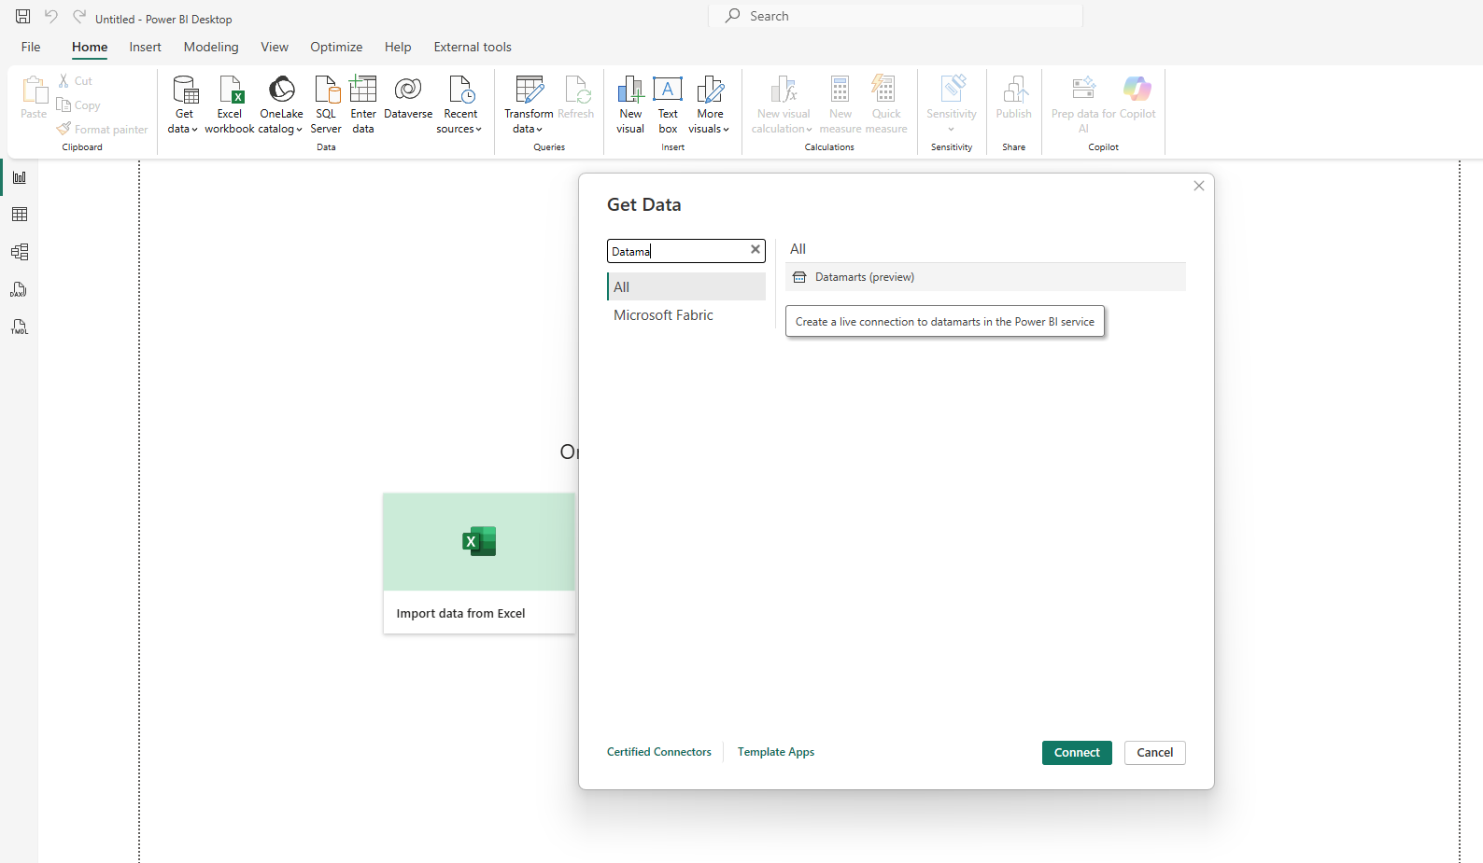
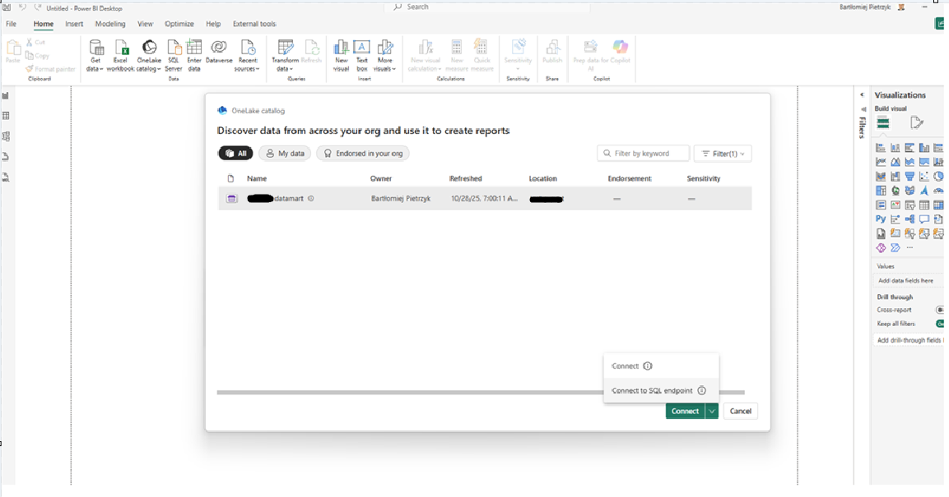

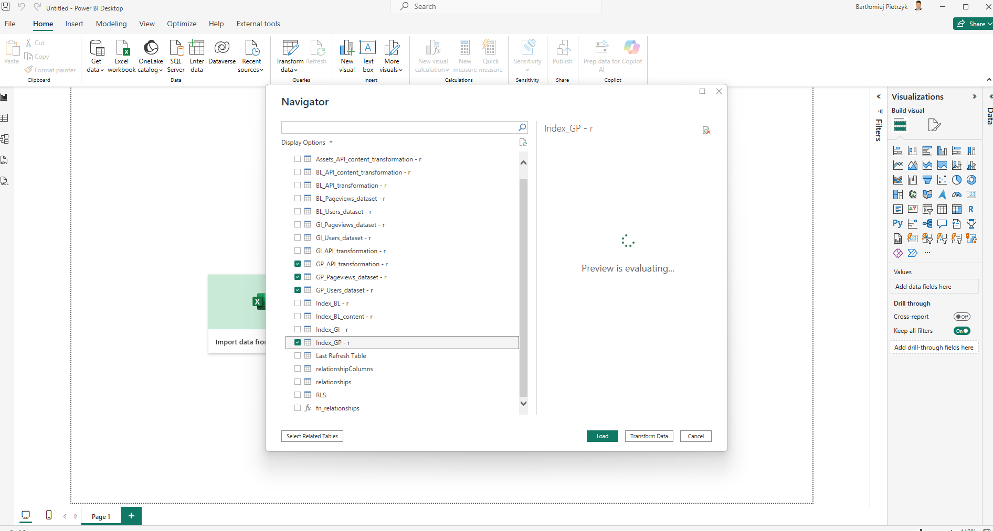
Transform data -> unable load for index -> close and apply -> add date tables
Refer to Global Industries for detailed screenshots of above described.
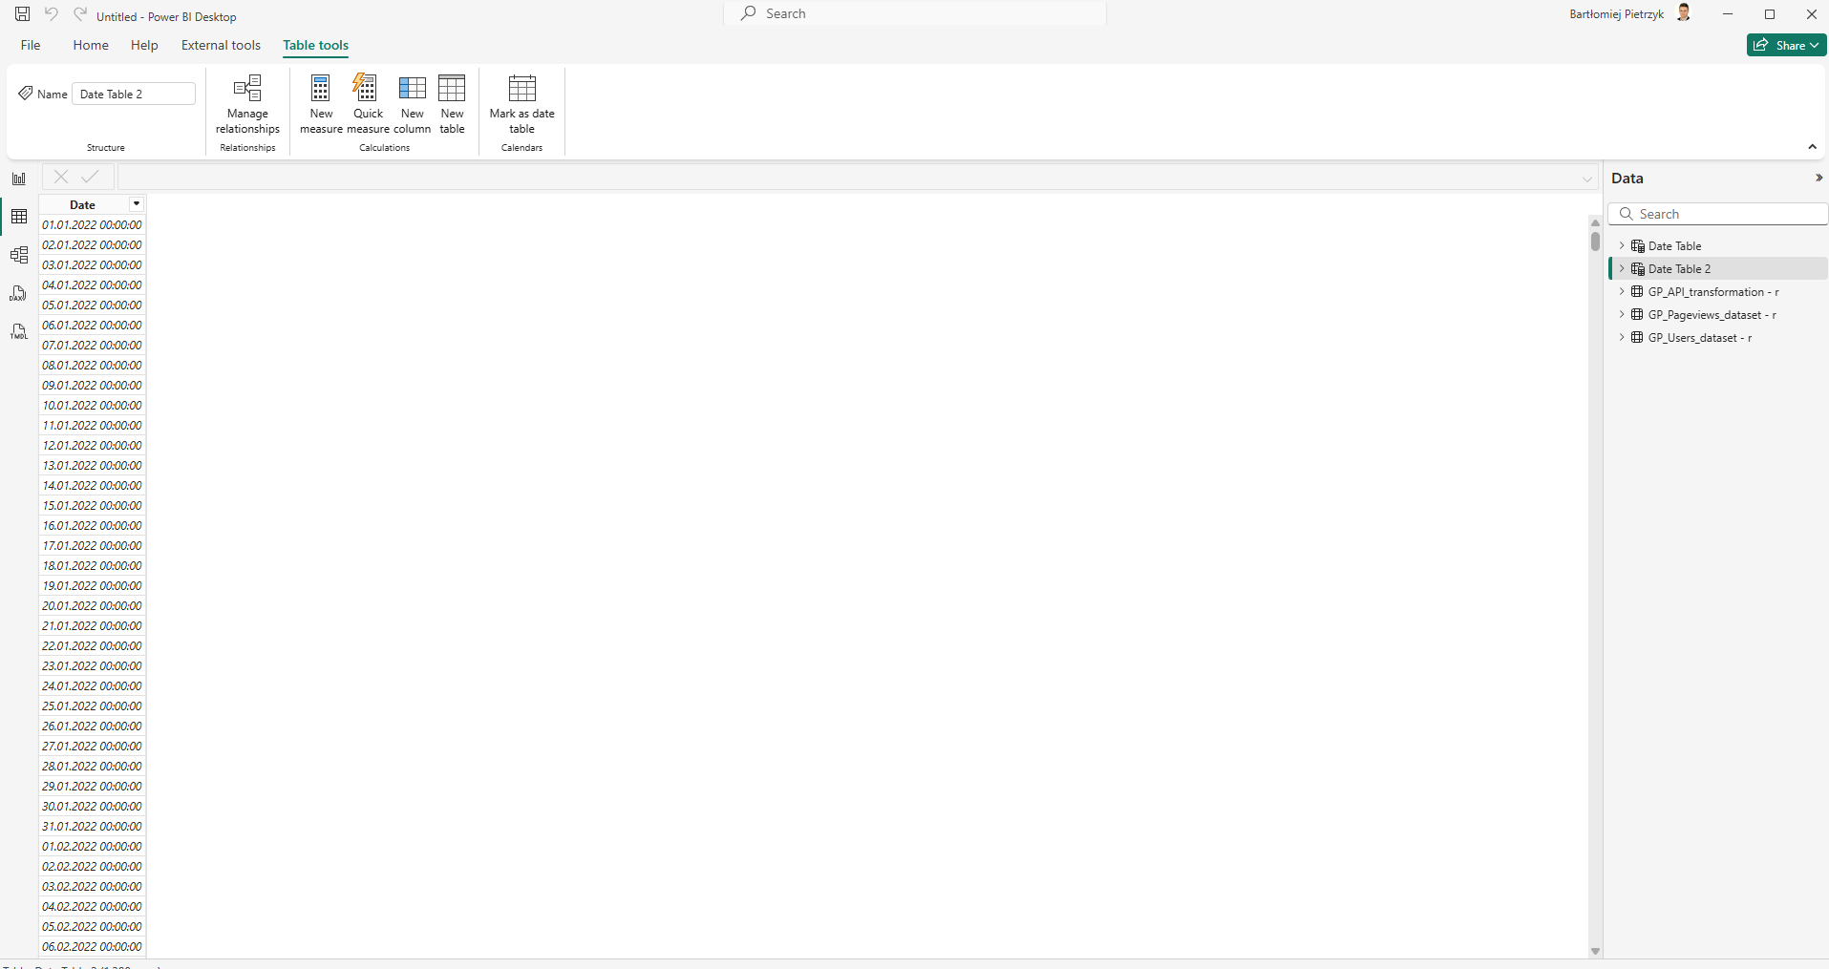

Go to manage relationships and assign accordingly
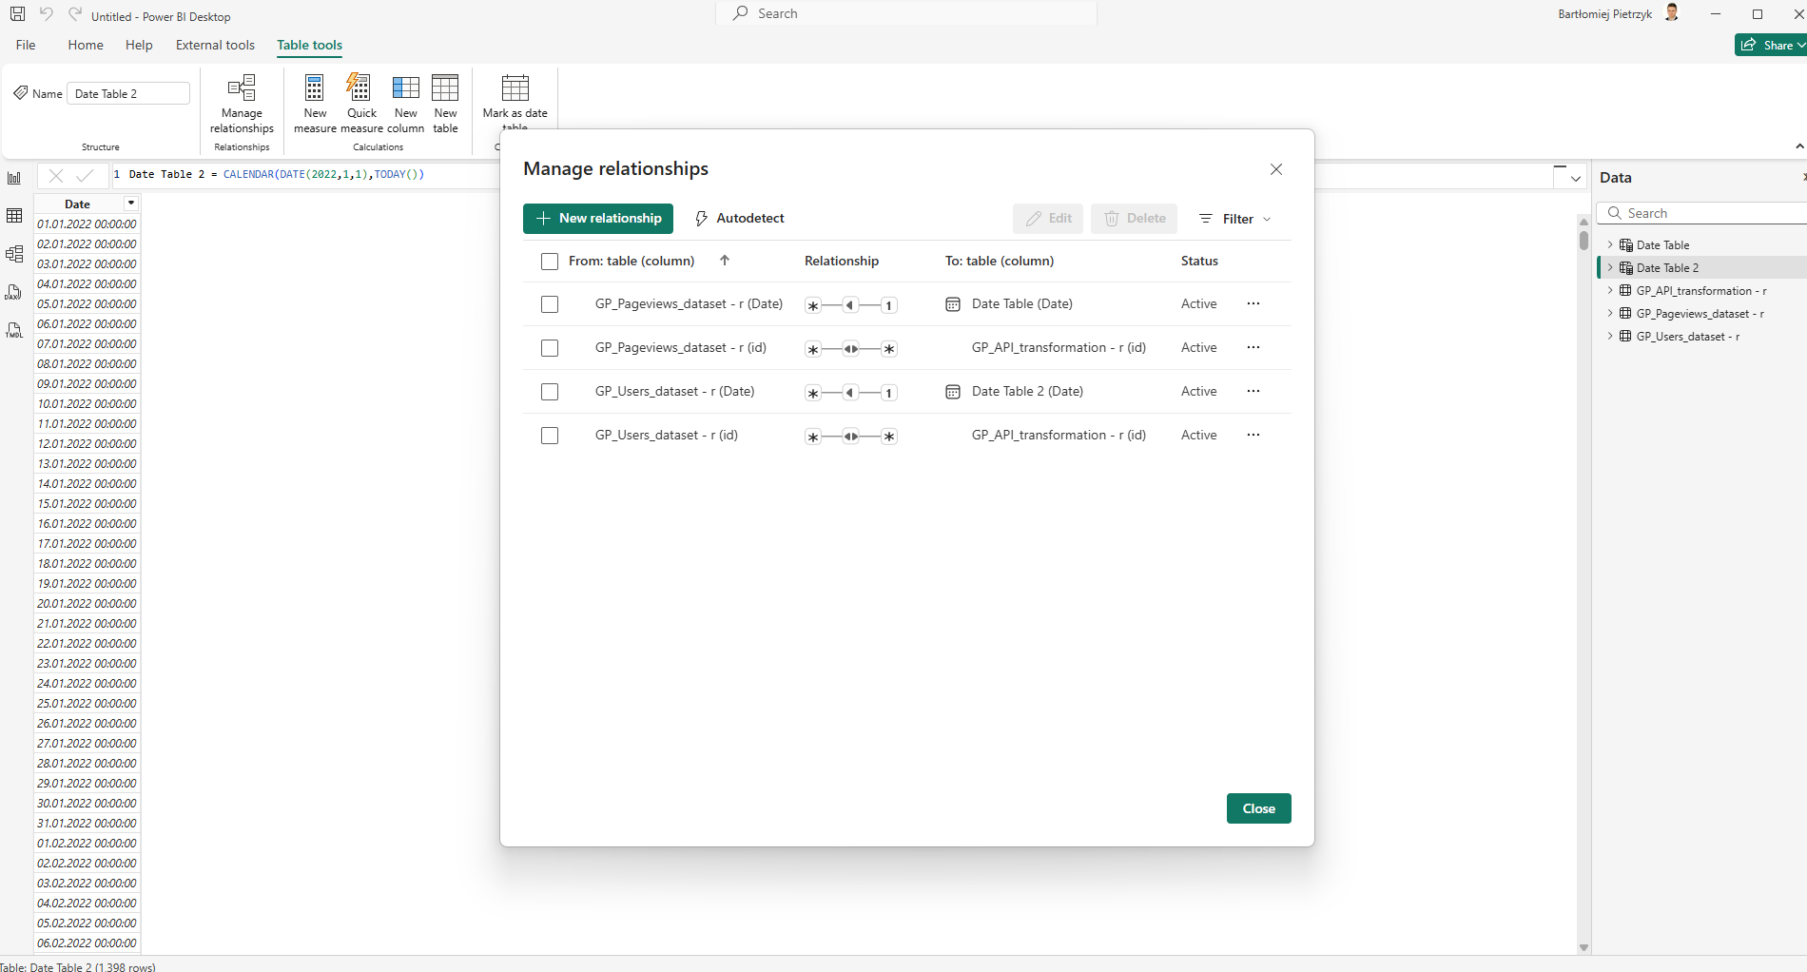
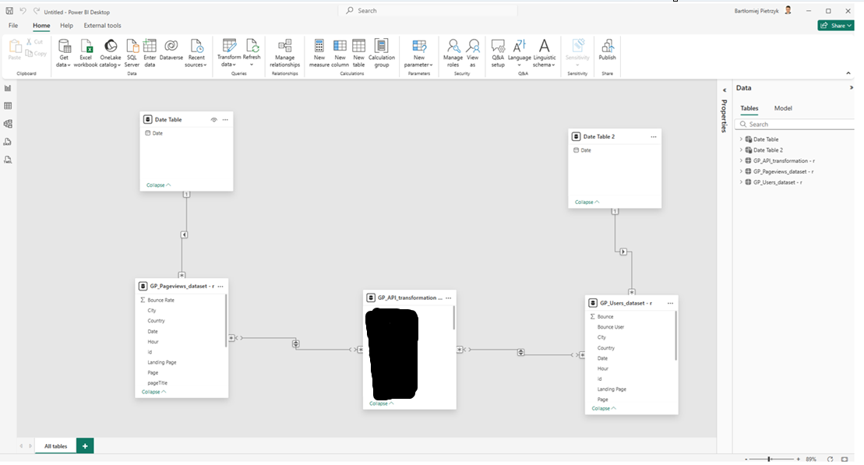
Forgot refresh table.
Publish the report to Power BI Service.

